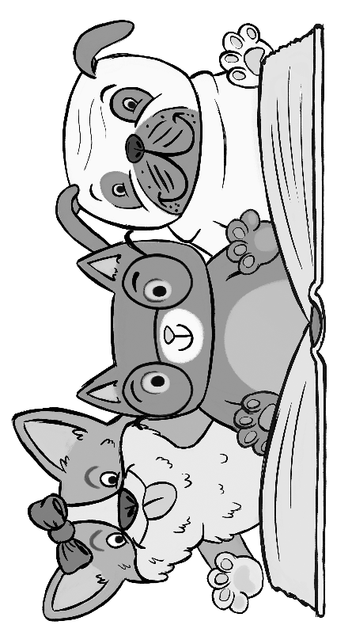
The Paw Print Press
Scholastic “Paws for Books”
Bookfair 2018

BOOK FAIR DATES: TUE.-FRI., FEB. 20-23 / FAMILY NIGHT: THU., FEB. 22 FROM 6-8PM
Tuesday  Feb. 20 | Wednesday  Feb. 21 | Thursday  Feb. 22 | Friday  Feb. 23 | Student Shopping Times  Students will be shopping each day during their media time. Parents are welcome to come shop with their child, or even better… VOLUNTEER during that slot to help the students with shopping and checkout.  Parents please note that your child’s class will only visit the Book Fair once this year!  CAMPUS SCHOOL ONLINE FAIR: 2/16-3/8  http://www.scholastic.com/bf/campusschool
 | 8:05-9:15  Cassidy 5th |  | 8:30-9:30  Cordero 5th
 | 9:25-10:35  Kay 4th | 9:25-10:35  Shadow 4th | 9:40-10:40  Ayers 4th
10:40-11:50  Osias 3rd |  | 10:40-11:50  Smith 3rd | 10:50-11:50  Krueger 3rd
12:20-1:30  Reese 2nd | 12:20-1:30  Alles 2nd | 12:20-1:30  Hembree 2nd | 12:30-1:30  Osborn 2nd
1:40-2:40  Horsley 1st | 1:40-2:40  Scarbrough 1st | 1:40-2:40  Adams 1st | 1:40-2:40  Friedman 1st

Family Night at the Book Fair!  Thursday, 2/22 from 6-8pm  - Book Fair Shopping  - Character Parade (6:30-7:00)  - Food Trucks  - Mrs. Ardrey’s Art Show  - Special Guest Readers  - Furry Friends  Ask Mrs. Smith how to win Scholastic Dollars to shop with at the Book Fair! | It Feels Great to Give Back!  Bring Coins! All For Books coin change collection will run all week long! Scholastic matches the total amount collected and donates that amount in books to a school or children’s charity in need.  Help us connect with our furry friends by also bringing an item to donate to the Humane Society of Memphis!  - Clean blankets and large towels  - Baking Soda  - Small or soft dog treats  - Cat treats  - Squeaky toys and chew toys
WE NEED VOLUNTEERS! SIGN UP GENIUS:
QUESTIONS? Ask Mrs. Smith or email Michele Mallory michelemallory@comcast.net

